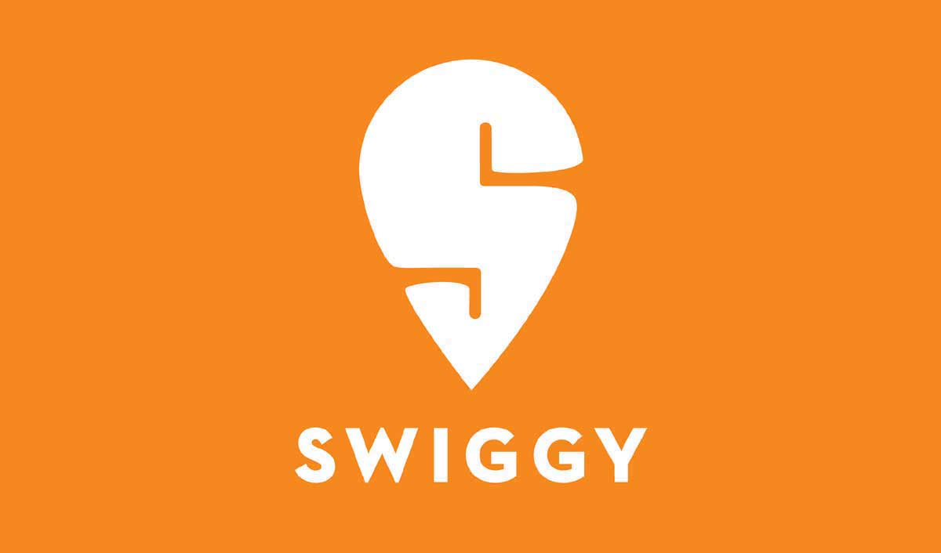

BUSINESS CASE : SWIGGY

*This Analysis is devided in six parts which contains-*

BY -

GUNANSH TRIVEDI

[Date]

* *Increase or decrease in the number of orders.*
* *Change in traffic as compared to same day last week.*
* *Change in Overall Conversion.*
* *Insights*
* *Recommendations*
* *Summary*
* ***About the company –***

*Swiggy is one of the largest food ecommerce platform in the country. Every day more than 1 million users are transacting on the platform. It provides quick pick and drop food delivery application to make the life of people simpler. It gives a single window to request from an extensive variety of restaurants along with an entire food entering and conveyence arrangement that connects neighbourhood eateries and foodies*.

**Swiggy app working model in eight simple steps**

* Users sign up for Swiggy mobile app and become customers
* Customers open the app, select the restaurant, and order the food
* The app confirms the delivery location
* The restaurant receives the order and confirms it
* Local delivery boy confirms the pick-up and drop location of the order
* Customers receive the notification showcasing the confirmation of the order and the person who will deliver the order
* Customers track the entire journey from mobile app starting from the order confirmation to the moment order gets delivered. They can also track the delivery boy’s location.
* 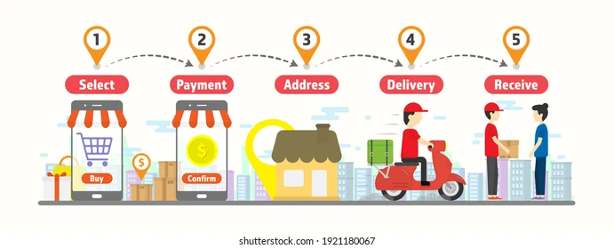Swiggy marks your ordered completed, once delivered
* **DATA COLLECTION –**

*Firstly, we will collect all the data according to date of order hike and drop.*

* Date of highs and lows in the orders with respect to same day last week

So , let’s start from the beginning of the year 2019 and as we can see the first week orders are shown below-

|  |  |  |  |  |  |  |  |  |  |  |  |  |  |  |  |  |  |  |  |  |  |  |  |  |
| --- | --- | --- | --- | --- | --- | --- | --- | --- | --- | --- | --- | --- | --- | --- | --- | --- | --- | --- | --- | --- | --- | --- | --- | --- |
| |  |  |  | | --- | --- | --- | | **Date** | **Listing** | **Orders** | | 01-01-2019 | 20848646 | 1271573 | | 02-01-2019 | 21934513 | 1261133 | | 03-01-2019 | 20848646 | 1138655 | | 04-01-2019 | 21717340 | 1296620 | | 05-01-2019 | 42645263 | 1596026 | | 06-01-2019 | 43543058 | 1582881 | | 07-01-2019 | 22803207 | 1123504 | |

* *Now we will start analysing the possible reasons for any order drop and hike as compared to last same day last week.*

|  |
| --- |
| **Date Analysis** |
| 1. ***10-01-2019(-45%) =*** *The channel wise traffic (Facebook, Youtube, twitter) was decreased on this day may be due to -*  * *some network issues* * *internet ban in some regions****.*** |
| 1. **17-01-2019(+106%)=** *Back to normal on the same day next week as a result the orders are also back to normal.* |
| 1. **21-01-2019(+23%)=** *There was a greater M2C and C2P conversions.* |
| 1. **22-01-2019(+85%)=** *Traffic on twitter was increased very much as a result the orders increased.* |
| 1. **29-01-2019(-72%)=** *The L2M conversions are very low because very less restaurants were active on this day due to which the overall orders decreased.* |
| 1. **05-02-2019(+115%)=** *As the Count of active restaurants increased the L2M conversions also increased and as a result the overall orders also increased as compared to the last week same day.* |
| 1. **19-02-2019(-56%)=** *The M2C conversions was very low so the overall orders decreased.* |
| 1. **26-02-2019(120%)=** *As the M2C conversions become normal then the orders are also back to the normal.* |
| 1. **28-02-2019(+22%)=** *Number of images per restaurant was high on this day so, customers ordered slightly more than the same day last week.* |
| 1. **02-03-2019(-38%)=** *On this day the C2P conversions are very low as compared to other days because the average delivery charge was HIGHEST on this day due to any reason.* |
| 1. **09-03-2019(+102%)=** *As the average delivery charges came to normal as other days then the orders also increased to normal.* |
| 1. **19-03-2019(-46%)=** *On this day the P2O conversions are very less as a result the overall success rate of payments declines.this could be due to technical glitches , shortage of active delivery agents ,etc.* |
| 1. **24-03-2019(+22%)=** *Due to weekend a slight hike in orders was seen here.* |
| 1. **26-03-2019(+78%)=** *As the P2O conversions became normal the orders also increased as compared to same day last week and also on this day the average packaging charges was less as compared to other days.* |
| 1. **04-04-2019(-52%)=** *The M2C conversions were less on that day because the average discount was very low as compared to other days.* |
| 1. **11-04-2019(+92%)=** *As the average discounts increases the orders also increases.* |
| 1. **14-04-2019(+28%)=** *Due to weekend the orders and traffic increased slightly.* |
| 1. **18-04-2019(+73%)=** *The average discounts was highest on this day due to which the orders also increased, Due to any festival or something.* |
| 1. **25-04-2019(-39%)=** *As the discounts decreases the orders also decreases and came back to normal.* |
| 1. **20-06-2019(-54%)=** *The channel wise traffic on facebook, youtube, twitter and others was very low on this day so, order decreases on this day. It could be due to any network issues .* |
| 1. **27-06-2019(115%)=** *As the channel wise traffic increases the orders and overall traffic also increases.* |
| 1. **16-07-2019(-63%)=** *The L2M conversions was very less on this day as compared to other days because the average cost for two is highest on this day. So, less number of people proceed to menu on this day.* |
| 1. **23-07-2019(+135%)=** *As the average cost for two decreases the orders increases back to normal.* |
| 1. **11-08-2019(-54%)=** *The average packaging charges were HIGHEST on that day due to which the C2P conversions decline very much and as a result the order decreased.* |
| 1. **18-08-2019(+107%)=** *As the average packaging charges decreases the orders increases back.* |
| 1. **14-09-2019(-54%)=** *The out of stock items per restaurant was very HIGH due to which the M2C conversions decreases and as a result the order decreases. It could be due to unavailability of a particular raw material.* |
| 1. **21-09-2019(+112%) =** *The items were back in stock so there were more options for the customer to choose and as a result the orders increases .* |
| 1. **21-10-2019(+32%)=** *This increase could be due to some occassions or festival.* |
| 1. **09-11-2019(+26%)=** *Due to weekend their was a slight increase in orders because their was more channel wise traffic as more number of customers were active on weekends.* |
| 1. **17-11-2019(-57%)=** *The out of stock items per restaurant was HIGHEST on that day due to which the M2C conversions were very low and as a result the overall orders decreased.* |
| 1. **24-11-2019(+135%)=** *The items were back in stock and available for delivery and also it was a weekend as a result the orders increased.* |

* Change in traffic as compared to same day last week

|  |
| --- |
| **Date Analysis** |
| 1. **10-01-2019(-49%) =** *The channel wise traffic (Facebook, Youtube, twitter) was decreased on this day may be due to some network issues or internet ban in some regions****.*** |
| 1. **17-01-2019(+110%) =** *Back to normal on the same day next week as a result the orders are also back to normal.* |
| 1. **22-01-2019(+77% )=** *The listings were more than normal other days because of more traffic on facebook and HIGHEST traffic on twitter may be due to any occasion offers or festival offers as a result the traffic was more.* |
| 1. **29-01-2019(-40%) =** *The L2M conversions was decreased on this day because of very less restaurant were active on that day due to which the traffic also decreased.* |
| 1. **20-06-2019(-53%) =** *The traffic on facebook, youtube, twitter and others decreased due to some technical issues and marketing issues as a result the overall listings decreased .* |
| 1. **27-06-2019(+119%) =** *As the channel wise traffic increased, the overall traffic was also increased.* |

* Change in Overall Conversion as compared to previous dates

|  |
| --- |
| **Date Analysis** |
| 1. **29-01-2019(-52%) =** *The L2M conversions are very less as compared to other days it was due to-*  * *Less number of restaurants active on that day as compared to other days.* * *It could be due to some staff problem , holiday in particular region, etc.* |
| 1. **05-02-2019(+115%) =** *As more restaurants became active the overall conversion increased.* |
| 1. ***19-02-2019(-54%) =*** *The M2C conversions was very low on that day .* |
| 1. **26-02-2019(+116%) =** *As the M2C conversions increased the overall conversions also increased.* |
| 1. **02-03-2019(-42%) =** *The C2P conversions was very less on that day due to –*  * *Average delivery charges was very high on that day.* * *May be due to delivery boy unavailability.* * *Weather conditions.* * Vehicle problems. |
| 1. ***09-03-2019(+102%) =*** *As the C2P conversions increased the overall conversions also increased.* |
| 1. **19-03-2019(-47%) =**  *The P2O conversions was very less as compared to other days due to –*  * *Technical glitches* * *Shortage of staff* * *All mode of payment options not available.* |
| 1. **26-03-2019(+87%) =** *The problem resolved and the P2O conversions increased on same day next week and as a result the overall conversions also increased.* |
| 1. **04-04-2019(-53%) =** *The M2C conversions were very low due to following reason –*  * *The average discount was very less as compared to other days.* |
| 1. **11-04-2019(+107%)** *= The M2C conversions increased after the increase in the average discount as a result the overall conversions also increased.* |
| 1. **18-04-2019(+57%) =** *The M2C conversions increased on that day due to following reasons –*  * *Average discount was highest on that day.* * *It could be due to any festival or occasion .* * *It could be due to some holiday.* |

|  |
| --- |
| 1. **25-04-2019(-39%) =** *As the average discount decreased the M2C conversions also decreased as a result the overall conversions decreased.* |
| 1. **16-07-2019(-59%) =** *The L2M conversions was very less on that day as compared to other days due to –*  * *Average cost for two was highest on that day. So, less number of people proceed to menu on that day.* |
| 1. **23-07-2019(+128%) =** *As the average cost for two decreases the overall conversion increases back to normal.* |
| 1. **11-08-2019(-54%) =** *The C2P conversions decreased due to –*  * *Average packaging charges was highest on that day.* * *It could be due to some shortage of packaging material.* * *More efficient packaging needed due to some weather conditions.* |
| 1. **18-08-2019(+100%)=** *As the average packaging charges decreases the overall conversions increases back.* |
| 1. **14-09-2019(-51%)** *=**The M2C conversions decreased due to -*  * *The out of stock items per restaurant was very HIGH .* * *It could be due to unavailability of a particular raw material.* |
| 1. **21-09-2019(+114%) =** *The items were back in stock so there were more options for the customer to choose and as a result the overall conversions increased .* |
| 1. **17-11-2019(-54%) =** *The M2C conversions decreased due to -*  * *The out of stock items per restaurant was highest .* * *It could be due to unavailability of a particular raw material.* |
| 1. **24-11-2019(+124%) =** *The items were back in stock so there were more options for the customer to choose and as a result the overall conversions increased .*  * *Also due to weekend the overall conversions was increased.* |

* ***Some charts related to the analysis –***

* ***Hypotheses on what could be the possibility for fluctuation in conversions –***

1. L2M
2. M2C
3. C2P
4. P2O
5. *L2M – It could be affected due to following reasons-*

* *Traffic on online paltforms*
* *Number of active restaurants*
* *Discounts*
* *Images of restaurants*

1. *M2C - It could be affected due to following reasons-*

* *Items in stock and ready to deliver*
* *Images of dishes*
* *Price of items*
* *Average cost for two*

1. *C2P - It could be affected due to following reasons-*

* *Mode of Payment options*
* *Coupons and offers*
* *Discounts*

1. *P2O - It could be affected due to following reasons-*

* *Technical issues*
* *Delivery boy unavailability*
* *Network issues*

** **INSIGHTS**

* *The channel wise traffic on –*

1. *Facebook*
2. *Youtube*
3. *Twitter*

*The traffic on these platforms is directly proportional to orders as the traffic on these platforms increases the orders increases and as the traffic decreases the orders also decreases.*

* *Overall conversion depends on following metrics –*

1. *L2M*
2. *M2C*
3. *C2P*
4. *P2O*

*If there is a decrease in any of the conversions than the overall orders and conversions also decreases and if there is a increase in these metrics than the overall orders also increases.*

* *These factors also affect the overall conversions and orders –*

1. *The count of restaurants active*
2. *Average discounts*
3. *Average packaging charges*
4. *Average cost for two*
5. *Out of stock items*
6. *Number of images per restaurant*

***RECOMMENDATIONS***

1. *First and most important is the marketing for our product and services . so, we need to design a great marketing strategy because the traffic on our online platform is directly proportional to the conversions and orders.*

* *For marketing we can use -*
* ***3C’S Framework***

*Customer Company*

* The strategies that were performing good in past
* Customer demands
* Type of customers

*Competetion*

* Market share and growth
* Tools used by compitetors for marketing

* ***4P’S Framework***

*Product Place*

*Price Promotions*

* *RFM SCORE*

*Recency Monetory*

*Frequency*

1. *After marketing the product/service let’s say the traffic has reached our swiggy platform. So, the next step is to convert the customers for this we need to devide the process in four parts –*
2. *L2M*
3. *M2C*
4. *C2P*
5. *P2O*
6. *L2M –*

* *Listings page should display images and offers very neately*
* *Platform should be smooth to operate*
* *It should be in a manner that attracts the customers*
* *There should be enough good quality images of restaurants*

1. *M2C –*

* *Ratings – always ask customer for giving a good rating and try to maintain a good rating . so, that it attracts the other customers.*
* *Price - The price should be such that it is affordable for customers and also good for the business.*
* *Reviews – Good review should be there.*
* *Images - Good quality images of dishes should be there.*
* *Offers – offers should be displayed neately.*

1. *C2P –*

*It depends on -*

* *Offers*
* *Coupons*
* *Delivery charge should be less*
* *Packaging charges should be less*

1. *P2O –*

* *Various payment modes should be available there*
* *No technical glitch should take place*
* *Tie up with banks and logistics services for providing smooth operations*

1. *Other factors –*

* *The count of restaurants active should be as much as possible always*
* *If a restaurant is deactive than ask the owner “Why is it deactive ?” or if any technical issue*
* *Ask the owner of restaurants to arrange all the items in advance which are needed for preparations of food which are listed on the swiggy platform. So, that there is less chances of items to get out of stock*
* **SUMMARY**
* ***In this report we have worked on the swiggy food delivery and we have analyzed the following points –***
* *Increase/decrease in the orders with respect to same day last week and the possible reason for hike & drop*
* *Change in traffic as compared to same day last week*

* *Change in overall conversion as compared to previous dates*
* *The possible reason of fluctuations in the metrics (L2M , M2C , C2P , P2O )*
* ***INSIGHTS –***

*These are the possible reasons for the orders increase & decrease . so, all these insights mentioned above should be considered while planning for the business.*

* ***Recommendations –***

*All these frameworks and marketing strategy and other factors are recommended strongly to be applied. So, that we can increase the growth of the business.*